Collections provide a way of keeping different lists of binder documents around. There are two types of collection:
<$Scr_Ps::0> 1. Arbitrary collections. You can add any documents you want to these and drag and drop to have them in any order.<!$Scr_Ps::0><$Scr_Ps::1>
⁃ Suppose you are reading through your manuscript and realise that a number of sections have problems in them that you are going to need to solve. You could create a collection called “Problems” and add any problematic documents to it. You could then open that collection to work through the problematic documents.<!$Scr_Ps::1><$Scr_Ps::0>
2. Search collections allow you to save a search and re-run it at any time.<!$Scr_Ps::0><$Scr_Ps::1>
⁃ Suppose you are writing a novel and have used labels to record the point of view of each chapter. You could set up different search collections for each point-of-view character. Each search collection would search for the character name in the label. You could then open one of the collections to see only the chapters or scenes for a particular character.<!$Scr_Ps::1><$Scr_Ps::2>
Opening Collections<!$Scr_Ps::2>
In the toolbar:
<$Scr_Ps::0> • Click on the “View” button on the left.
• Select “Collections”.<!$Scr_Ps::0><$Scr_Ps::1>
⁃ An area will appear at the top of the binder containing three rows (tabs), “What’s New in Scrivener 3”, “Binder” and “Search Results”.<!$Scr_Ps::1><$Scr_Ps::0>
• Click on the “Search Results” row.<!$Scr_Ps::0>
See what happened? The last search you ran gets run again, and its results appear where the binder was.
Click on the “Binder” tab to return to the binder before continuing.
<$Scr_Ps::2>Arbitrary Collections<!$Scr_Ps::2>
To create an arbitrary collection:
<$Scr_Ps::0> • Right-click on this document’s header view document icon to bring up the header bar menu.<!$Scr_Ps::0>
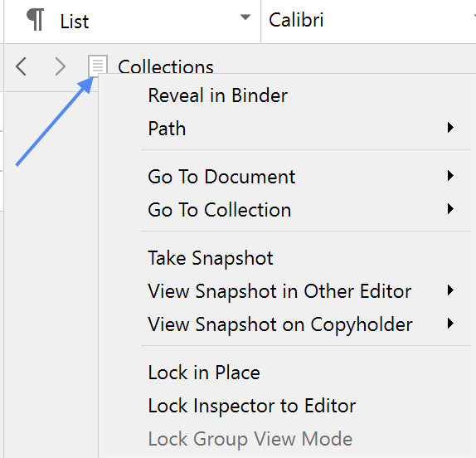
<$Scr_Ps::0> • Select “Lock in Place”:<!$Scr_Ps::0>
￼
The header bar will turn pink, indicating that the editor is now “locked”. When an editor is locked, clicks in the binder will have no effect. Try clicking on different documents in the binder to see what I mean—they will no longer get loaded into the editor when selected as they normally do. We have locked the editor so that you can still read this document while trying out the following steps.
<$Scr_Ps::0> • Hold down the Ctrl key on the keyboard and select several documents in the binder.
• Once you have selected five or six (it doesn’t matter which), click on “+” button in the “Collections” bar at the very top of the binder:<!$Scr_Ps::0>

￼
The binder will be replaced by a flat list showing only the documents you selected. You haven’t moved those documents—they are all still in their rightful places in the binder. No, you’ve just created a collection. When you created it, the selected documents were automatically added to it.
To see what I mean click on one of the documents in the collection list and go to <$Scr_Cs::3>Navigate > Reveal in Binder<!$Scr_Cs::3>, or right-click and select “Reveal in Binder”. This shows you where the document is located in the binder.
Click back on the collection tab that was created once you’ve tried this, to return to the collection.
<$Scr_Ps::0> • You can drag and drop the collection rows into any order you want.
• You can drag and drop documents inside the collection list to reorder them. (This has no effect on the order in the binder.)
• You can rename the collection to anything you want, and you can change its colour by clicking on the little chevron next to the collection name:<!$Scr_Ps::0>
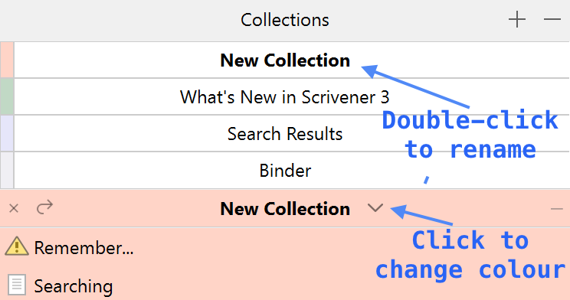
￼
Go ahead and try changing the title and colour of the collection you created.
Let’s add some more documents to the collection:
<$Scr_Ps::0> • Click back on the “Binder” tab and select some different documents in the binder.
• Once you’ve selected some documents, drag and drop them onto the collection tab.<!$Scr_Ps::0>
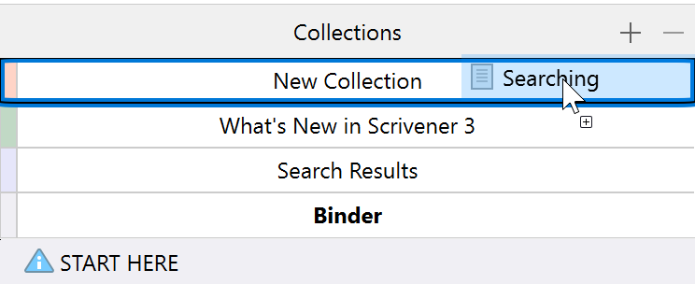
<$Scr_Ps::0>￼
• The documents you dragged onto the tab are now in the collection too.<!$Scr_Ps::0><$Scr_Ps::2>
Search Collections<!$Scr_Ps::2>
Let’s create a collection of all documents with their status marked “To Do”:
<$Scr_Ps::0> 1. Open project search by clicking on the magnifying glass in the toolbar.
2. In the search field that appears above the binder, search for “To Do”. The binder will be replaced with the purple search results list.
3. Click on the magnifying glass icon on the left of the search field and select “Status” from the menu that appears. The search results will update to show only documents with a status of “To Do”.
4. Click on the the magnifying glass in the search field again, and this time select “Save Search As Collection…” from the bottom of the menu.
5. Enter a name for the search, e.g. “To Do” (it will use the search phrase by default) and hit “OK”.<!$Scr_Ps::0>
The search results will now change colour and you will see that a new tab has appeared in the list of collections named “To Do”. Again, you can rename this or change the colour to one of your choosing, just as you can with arbitrary collections.
Search collections are different to arbitrary collections in that you can’t add documents to them or move them around. Instead, every time you click on a search collection, the search gets run again. To see what I mean:
<$Scr_Ps::0> 1. Click back on the “Binder” tab.
2. Click on the “START HERE” document at the top of the binder and hit the space bar to bring up a Quick Reference panel.
3. Click on the “No Status” pop-up button in the bottom-right of the Quick Reference panel and choose “To Do” from the status menu.
4. Repeat this with a couple of other documents if you like.
5. Now click on the “To Do” collection again.<!$Scr_Ps::0>
The “START HERE” document is now part of the “To Do” collection.
<$Scr_Ps::2>Deleting Collections<!$Scr_Ps::2>
To delete a collection, simply select its tab and then click on the “-” button in the “Collections” header bar (you will be prompted to confirm the deletion). Deleting a collection has no effect on its constituent documents—they are not deleted and remain in their place in the binder.
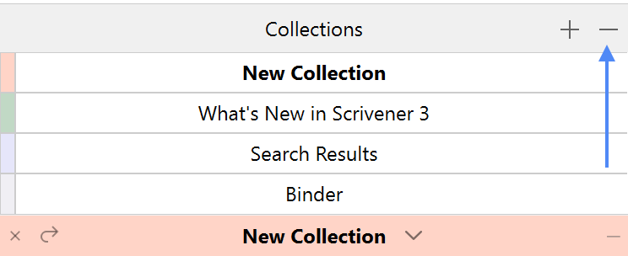
<$Scr_Ps::2>Closing Collections<!$Scr_Ps::2>
You can close a collection and return to the binder at any time by clicking the “X” button in the left of the collection header bar:
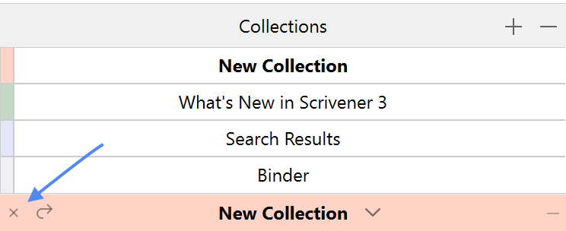
￼
You can now unlock the editor by right-clicking on the editor header bar document icon again and deselecting “Lock in Place”. You can also hide the collections tab by choosing “Collections” from the “View” toolbar button menu.

